**IT Sector in Ireland today**

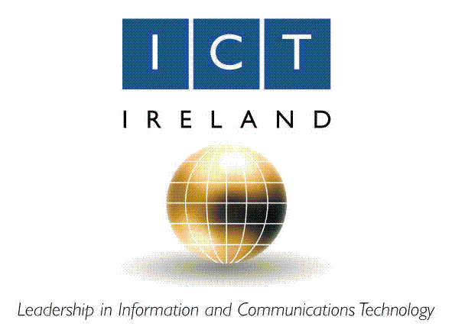

**Joseph Tierney**

**Computer Science 1B**

**Work Experience**

**IT Sector in Ireland Structured Report**

**Ulrike McMahon**

**Contents**

1. Introduction
2. IT Sector in Ireland
3. Employment in the IT Sector
4. Computer Programming
5. Conclusion
6. Bibliography
7. Introduction

Information and Communication Technology, commonly known as ICT, refers to technologies that provide access to information through means of telecommunications.

The Information, Communications and Technology Sector surrounds many different activities and companies today. Based on two main principles, the definition of the IT Sector is based on the following:

For manufacturing industries, for incorporation in the IT sector, the results of the business must be proposed to satisfy the current amount of data handling and correspondence, including communication and showcase, and they must use electronic preparing to identify, measure and record “physical phenomena or to control a physical process”.

For service industries, the results of an industry must be expected to enable the capacity of data processing and communication by electronic means.

The ICT (Information and Communications Technologies) sector will keep on providing employment and development opportunities for the Irish workforce and economy (according to the Expert Group on Future Skills Needs).

1. IT Sector in Ireland

The IT Sector incorporates a wide range of technology and activities. Within Ireland, the ITT sector includes the development of hardware and devices, operating systems and software, digital content, outsourcing, data supply and storage.

Ireland is the second largest exporter of computer and IT services in the world. With a very innovative and gifted workforce, an open economy and a focused corporate duty environment, Ireland has effectively pulled in eight of the main 10 worldwide information technology companies to build a significant presence here.

Intel, HP, IBM, Microsoft and Apple, the long established companies have been joined by developing and new firms leading the internet and social media, such as Google, Facebook and Twitter. Ireland has now been positioned as the internet capital of Europe thanks to these social media outlets.

In Europe, Ireland is the data centre location of choice for IBM, Microsoft and Google. Gaming companies have also shared an interest in making an impact in Ireland, such as EA, Riot Games and Havok, all of which would make a compelling presence here.

The total amount of IT companies in Ireland is approximately 5,400, and only 233 of those companies are foreign owned.

1. Employment in the IT Sector

Since 2010, over 74,000 people are employed by IT companies in Ireland, according to the figures presented by CSO’s employment figures from that year.

Within the IT Sector, the high-tech manufacturing side is as of now encountering a 49 percent gap in technical skills and a 47 percent gap in other technical skills. The sector is similarly, has come across extraordinary decreases in the area of IT project management and in addition IT experts with business management skills. There is also a continuous requirement for IT professionals with a foreign language background or foreign language skills.

Some of the main employment areas in the IT sector include: application developer, computer programmer, software engineer, electronics engineer, IT trainer, computer analyst, multimedia programmer and network engineer, as well as an abundance of others.

Careers in the IT sector all require a similar set of basic skills. Some of the main skills involved in the IT sector involve Mathematics, communication skills and being able to understand a range of perspectives is necessary. A degree in maths, computer science and/or computer engineering is a basic requirement for employment in the IT sector. As new programming languages are being developed, more certificates may be needed to understand them. A computer analyst would need excellent communication skills along with project management and troubleshooting skills. To prepare for this type of employment, a degree, or education in computer science would be a great way to go.

1. Computer Programming

While there are numerous exciting career opportunities in Information Technology, one that has been a first choice for many, and rather an overly popular choice throughout the years is computer programming. Statistics show that approximately 8 percent of the computer systems design industry is made up of computer programmers, and that in itself is still growing rather quickly. Between 2010 and 2020, there is a projected 72 percent increase for job development excepted, according to the Bureau of Labour Statistics. With there being such a high demand for the most recent and most popular software, as well as new and exciting programs being developed to this very day, computer programming itself can lead to a very successful career in information technology.

Computer programmers utilize their abilities to write code and make software programs that tell computers to achieve certain task, like fetching and retrieving data. They can also change the coding, be able to debug the programs they create, and test these programs. Specific codes, commonly known as computer languages are used in writing these programs, such as Java and C++, being the popular choices among programmers, to change the program designs made by software developers into instructions that the computer can follow.

Computer Programming, like most IT jobs, and jobs in general, requires skills and qualifications. Being able to program is a major skill needed. One must be able to write computer programs for various purposes. Critical thinking, complex problem solving, judgement and decision making are among various skills needed to advance in the computer programming job sector.

The standard for programmers is generally high, but companies like Microsoft Ireland offer jobs to those who don’t have the proper qualifications through their youth2work program, which offers a wide variety of courses to help get a job with them. Generally, most companies will look for a four year degree in computer science. Most employers also look for someone with a bachelor’s degree, however some will hire experienced programmers with an associate’s degree or certificate.

Currently, the IT sector industry is booming, and computer programming is showing signs of steady growth throughout the IT sector. Jobs are expected to increase to approximately 12 percent in the next six years, which is about normal growth for the industry. It’s been reported by US News and the World Report that computer programmers earn an average pay of roughly $71,000. US News and the World Report also reported that computer programming was named the fifth best technology job and the thirteenth job overall.

1. Conclusion

Currently in Ireland, the IT Sector is at its peak, with more than thousands of jobs still vacant for people just leaving college with their degrees, or people who have gone through Microsoft Ireland’s youth2work program. The IT Sector is set to peak between now and the year 2020, with no signs of slowing down. The IT Sector was the only employment area not affected by the global recession.

1. Bibliography

### MCHUGH, M.

#### Information, Communication and Techonology Sector in Ireland

**In-text:**(McHugh, 2010)

**Bibliography:**McHugh, M. (2010). *Information, Communication and Techonology Sector in Ireland*. [online] een ireland. Available at:

<http://www.een-ireland.ie/eei/assets/documents/uploaded/general/ICT%20Fact%20sheet.pdf>

[Accessed 20 Nov. 2014].

### FORFAS.IE

#### Strong Future and Opportunities for ICT Sector in Ireland - Forfás - Ireland´s Policy Advisory Board For Enterprise, Trade, Science, Technology and Innovation

**In-text:**(Forfas.ie, 2008)

**Bibliography:**Forfas.ie, (2008). *Strong Future and Opportunities for ICT Sector in Ireland - Forfás - Ireland´s Policy Advisory Board For Enterprise, Trade, Science, Technology and Innovation*. [online] Available at: <http://www.forfas.ie/newsevents/news/newsarchive/title,1013,en.php>

[Accessed 22 Nov. 2014].

### FIT.IE

#### FIT - Fast track to IT - Industry Leadership

**In-text:**(Fit.ie, 2014)

**Bibliography:**Fit.ie, (2014). *FIT - Fast track to IT - Industry Leadership*. [online] Available at: <http://www.fit.ie/index.php?page=industry-partners>

[Accessed 22 Nov. 2014].

### JOB-DESCRIPTIONS.CAREERPLANNER.COM

#### Computer Programmer Job Description, including skills needed - Part 3

**In-text:**(Job-descriptions.careerplanner.com, 2014)

**Bibliography:**Job-descriptions.careerplanner.com, (2014). *Computer Programmer Job Description, including skills needed - Part 3*. [online] Available at:

<http://job-descriptions.careerplanner.com/Computer-Programmers-3.cfm>

[Accessed 22 Nov. 2014].

### WGU.EDU

#### How to Become a Computer Programmer

**In-text:**(Wgu.edu, 2014)

**Bibliography:**Wgu.edu, (2014). *How to Become a Computer Programmer*. [online] Available at: <http://www.wgu.edu/blogpost/how-become-computer-programmer>

[Accessed 24 Nov. 2014].